Technical Support and E-Warranty Certificate www.vevor.com/support

Manual Lever Hoist
User's Manual

We continue to be committed to provide you tools with competitive price.
"Save Half", "Half Price" or any other similar expressions used by us only represents an estimate of savings you might benefit from buying certain tools with us compared to the major top brands and doses not necessarily mean to cover all categories of tools offered by us. You are kindly reminded to verify carefully when you are placing an order with us if you are actually saving half in comparison with the top major brands.

Manual Lever Hoist
Model: HS0.75-1.5, HS0.75-3, HS1.5-3 , HS1.5-6
HS3-3, HS3-6, HS6-3, HS6-6
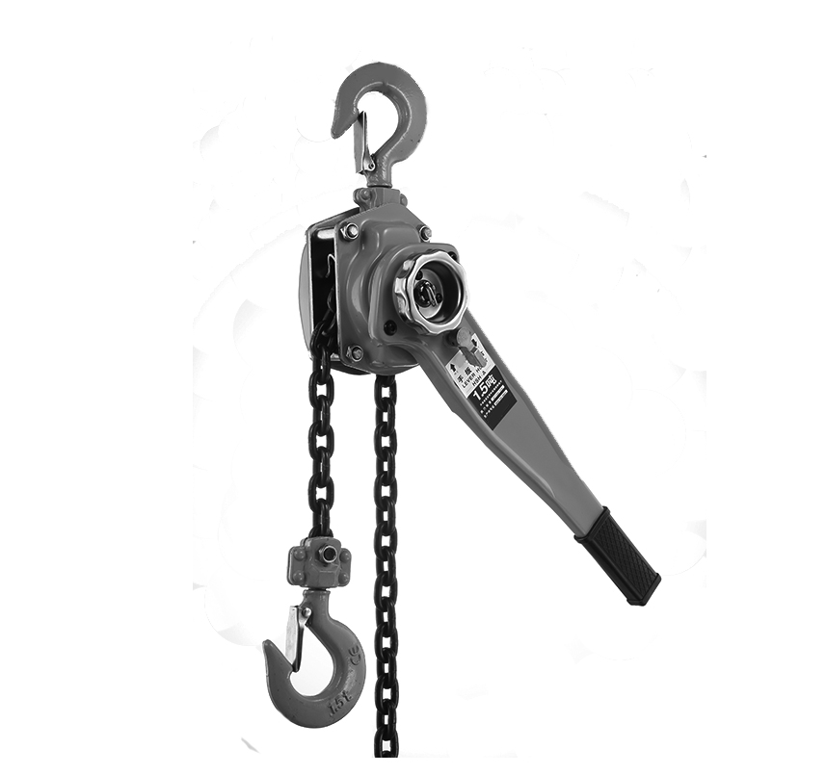
Have product questions? Need technical support? Please feel free to contact us:
CustomerService@vevor.com
NEED HELP? CONTACT US!
This is the original instruction, please read all manual instructions carefully before operating. VEVOR reserves a clear interpretation of our user manual. The appearance of the product shall be subject to the product you received. Please forgive us that we won't inform you again if there are any technology or software updates on our product.
SAFE INSTRUCTIONS

WARNING:
Before use, check if the machine parts are intact, the transmission part and lifting chain are well lubricated, the idling condition is normal, and the braking is reliable.
The following rules must be strictly observed during use.
1.It is forbidden to use two or more hoists to lift a heavy object at the same time.
2.Do not hang heavy objects that exceed the max. lifting capacity
3.It is forbidden to lift heavy objects at the tip of the hook and bind heavy objects with lifting chains.
4.The lifting and lowering of heavy objects shall not exceed the limit of the upper and lower movable distance.
5.It is not allowed to pull the weight diagonally and horizontally.
6.The chain shall not be used when it is twisted.
7.It is strictly forbidden for personnel to work or walk under the lifted load.
8.If the hand pull force is greater than the normal hand pull force, stop using it immediately and check it. Do not pull hard, let alone add people to pull hard.
9.Don't throw the hoist.

CAUTION: Carefully read instructions and procedures for safe operations.

Product Introduction
Model
SPEC. | HS0.75-1.5 | HS0.75-3 | HS1.5-3 | HS1.5-6 | HS3-3 | HS3-6 | HS6-3 | HS6-6
Max. Lifting Capacity | 3/4 t | 3/4 t | 1.5t | 1.5t | 3t | 3t | 6t | 6t
Max. Lifting Height | 5ft | 10ft | 10ft | 20ft | 10ft | 20ft | 10ft | 20ft
Material | Alloy Steel | Alloy Steel | Alloy Steel | Alloy Steel | Alloy Steel | Alloy Steel | Alloy Steel | Alloy Steel
Load Chain Size | 6*18mm  G80 | 6*18mm  G80 | 8*24mm  G80 | 8*24mm  G80 | 10*30mm  G80 | 10*30mm  G80 | 10*30mm  G80 | 10*30mm  G80
Normal Hand Pull Force | 140N | 140N | 240N | 240N | 320N | 320N | 340N | 340N
Color | Orange | Orange | Orange | Orange | Orange | Orange | Orange | Orange

Package Content
Model
Parts | HS0.75-1.5 | HS0.75-3 | HS1.5-3 | HS1.5-6 | HS3-3 | HS3-6 | HS6-3 | HS6-6
Mini Lever Chain Hoist | 1 | 1 | 1 | 1 | 1 | 1 | 1 | 1
User's Manual | 1 | 1 | 1 | 1 | 1 | 1 | 1 | 1

Product Diagram
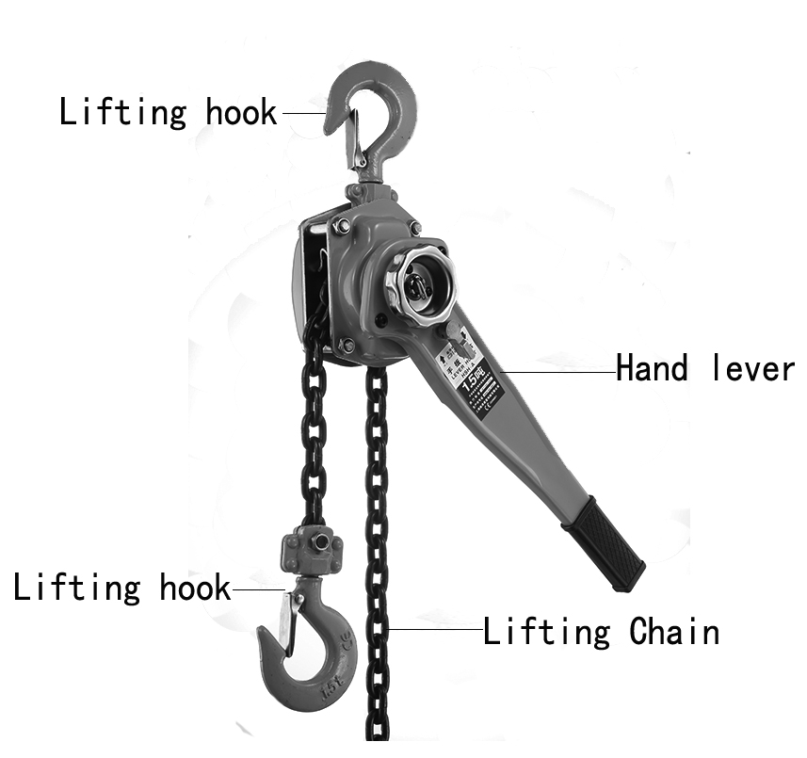
L
R
5
4
3
7
2
1
6
Fig. 1

1.Upper Hook 2. Protective Housing 3. Lower Hook 4. Load Chain
5. Hand Lever 6. Shift Handle 7. Hand-wheel

Installation Instruction
- First of all, ensure that the Manual Lever Hoist is firmly suspended and reliable.
- The suspension rod load must be greater than the weight of the weight and hoist.
- It is strictly prohibited to use the Manual Lever Hoist with overload.
- It is forbidden to operate with forces other than manpower.
5. Before use, carry out safety inspection on the Manual Lever Hoist, and carry out no-load test on the hoist, and reasonably adjust the position of the lower hook according to the actual requirements.
6. Before lifting, check whether the upper and lower hooks are fastened.
7. The adjustment method of the lower hook is as follows: turn the shift handle to "N" position, pull out the chain to easily adjust the position of the lower hook.
8. After the adjustment, hang heavy objects to ensure vertical suspension ,and there shall be no chain link with wrong twist, and pull the hand lever to lift the heavy objects.
9. When lifting heavy objects, it is strictly forbidden for personnel to do any work or walk under the heavy objects to avoid personal injury or accidents.
- Instructions of Shift Handle: ( Fig. 1)
- Turn the shift handle to the right “R”,swing the hand lever and the lower hook begins to drop.Turn the hand-wheel counterclockwise to slightly lower the lower hook.
- Turn the shift handle to the left “L”,swing the hand lever and the lower hook begins to raise.Turn the hand-wheel clockwise to slightly raise the lower hook.
- Turn the shift handle to the middle “N”, At this time, the clutch is open, Pull down the hook or chain to quickly adjust to the desired height. Turn the hand-wheel clockwise to slightly raise the lower hook; turn the hand-wheel counterclockwise to slightly lower the lower hook.

MAINTENANCE, AND REPAIR

1.After use, the hoist shall be cleaned and coated with anti-rust oil and stored in a dry place.
2.Maintenance and overhaul shall be carried out by those familiar with the hoist mechanism to prevent those who do not understand the performance principle of the mechanism from being removed at will.
3. After cleaning and maintenance, the hoist shall be subject to no-load and heavy-load tests, and can be delivered for use only when it is confirmed that the hoist works normally and the brake is reliable.
4. The friction surface of the brake must be kept clean, and the brake part should be checked regularly to prevent brake failure. Self-falling of heavy objects occurs.

TROUBLESHOOTING

Faults | Possible Reasons | Processing Method
Load Chain failure | Chain wear,  chain break | Replace a new chain
Load Chain jam | Chain wear,  Chain twist | Replace a new chain,  Comb it and hang it again
Brake failure | Break disc wear | Replace a new break disc

Importer: WAITCHX
Address: 250 bis boulevard Saint-Germain 75007 Paris
Importer: FREE MOOD LTD
Address: 2 Holywell Lane, London, England, EC2A 3ET

Manufacturer：Daimler(Hebei) Hoisting Machinery Manufacturing Co., Ltd
Add: Donglu Industrial Park,Qingyuan District,Baoding City,Hebei Pronvince

REP
UK
EUREP UK LTD
UNIT 2264, 100 OCK STREET, ABINGDON
OXFORDSHIRE ENGLAND OX14 5DH
REP
EC
EUREP GmbH
Unterlettenweg 1a, 85051
Ingolstadt, Germany

Made In China

Technical Support and E-Warranty Certificate
www.vevor.com/support

