INSTRUCTION
Thank you for buying VEVOR Electric Enclosure Cabinet or Box. Read this instruction carefully and make it fully understand before any operation,and Keep this instruction.
This item is designed to enclose electrical equipment or electronic device, protect it against harsh,dirty environments.
!! Warning
- Enclosure box/Cabinet is only coating but NOT insulated. ONLY qualified electrician could deal with the inside circuits and electrical parts. Warning Label or other signs could be posted according to relative laws or code if necessary.
- DO NOT Permit children to play with this item.
- The Electrical Enclosure box could be water proof ONLY all the holes has been sealed by soft gasket or plug. For the holes cut by customer, please use IP65 Grade Gasket or parts to keep waterproof.
- This item MUST BE GROUNDED. Please refer to the “mounting instruction-Assembly the earth wire”.
! Tips
- Any damage on the finish coating could lead rust, tiny surface damage could be repaired by re-painting. But it will not recommended when painting on large scale damages.
- The working temperature should be lower than 80°C，otherwise could lead the damage to the painting surface and the failure of sealing.

SPECIFICATION
- General
Color : RAL 7035 (White Gray) or RAL 2000 (Orange)
Body Material: Cold Rolled Carbon Steel
Inner plate: Galvanized Plate
Finish: Powder Coating (Surface Pickling and passivization)
Construction: Continuously Welded
Ambient Temperature: -40-55°C
Gasket Material： Seamless Foam/ Nylon(washer or plug)
Certification: TUV CE, UL 508A (CSA C22.2 No. 14-13.)
Ratings： NEMA Type 4
Protection Grade IP65, IK10

- Dimension
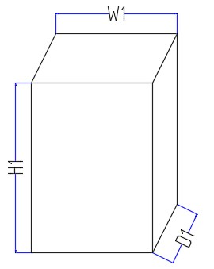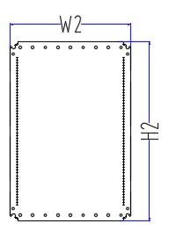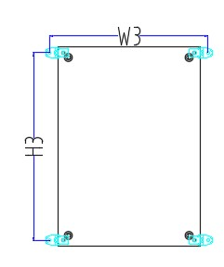

Unit: cm
Model No. | Enclosure |  |  | Inner Plate |  | Mounting Hole Setting（±0.2cm）
 | H1 | W1 | D1 | H2 | W2 | Dia. | H3 | W3
ST7520 | 70 | 50 | 20 | 66.5 | 45 | 0.9 | 66 | 55.6
ST6630 | 60 | 60 | 30 | 56.5 | 55 | 0.9 | 56 | 65.6
ST6620 | 60 | 60 | 20 | 56.5 | 55 | 0.9 | 56 | 65.6
ST6430 | 60 | 40 | 30 | 56.5 | 35 | 0.9 | 56 | 45.6
ST6425 | 60 | 40 | 25 | 56.5 | 35 | 0.9 | 56 | 45.6
ST6420 | 60 | 40 | 20 | 56.5 | 35 | 0.9 | 56 | 45.6
ST5510 | 50 | 50 | 10 | 46.5 | 45 | 0.9 | 46 | 55.6
ST5425 | 50 | 40 | 25 | 46.5 | 35 | 0.9 | 46 | 45.6
ST5420 | 50 | 40 | 20 | 46.5 | 35 | 0.9 | 46 | 45.6
ST5415 | 50 | 40 | 15 | 46.5 | 35 | 0.9 | 46 | 45.6
ST5325 | 50 | 30 | 25 | 46.5 | 25 | 0.9 | 46 | 35.6
ST4420 | 40 | 40 | 20 | 36.5 | 35 | 0.9 | 36 | 45.6
ST4415 | 40 | 40 | 15 | 36.5 | 35 | 0.9 | 36 | 45.6
ST4320 | 40 | 30 | 20 | 36.5 | 25 | 0.9 | 36 | 35.6
ST4315 | 40 | 30 | 15 | 36.5 | 25 | 0.9 | 36 | 35.6
ST3320 | 30 | 30 | 20 | 26.5 | 25 | 0.9 | 26 | 35.6
ST3315 | 30 | 30 | 15 | 26.5 | 25 | 0.9 | 26 | 35.6
ST32515 | 30 | 25 | 20 | 26.5 | 20 | 0.9 | 26 | 30.6
ST3220 | 30 | 20 | 20 | 26.5 | 15 | 0.9 | 26 | 25.6
ST3215 | 30 | 20 | 15 | 26.5 | 15 | 0.9 | 26 | 25.6
ST25215 | 25 | 20 | 15 | 21.5 | 15 | 0.9 | 21 | 25.6
ST2215 | 20 | 20 | 15 | 16.5 | 15 | 0.9 | 16 | 25.6

MOUNTING INSTRUCTION
Body installation
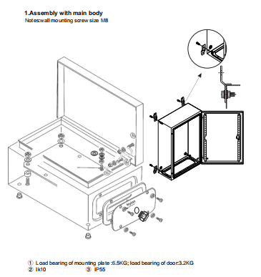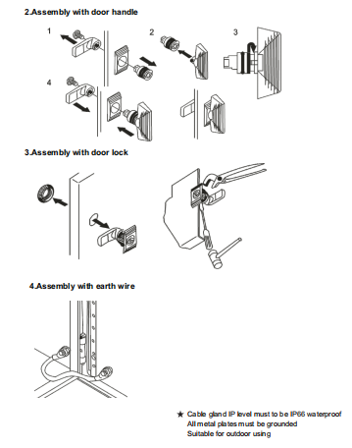

Accessories

Guide Rail x1Pc
Rain Hood x1Pc
Hanging Lug x4Pc
Gasket x1Pc (For Enclosing Plate)
Earth wire x1Pc
Accessories package x1set
-- Earth label x3pcs
-- Fasteners （Quantity Various on Type）
-- Key x2pcs
-- Plug x8pcs

