

Technical Support and E-Warranty Certificate [www.vevor.com/support](https://www.vevor.com/support" \t "_blank)

**Electric Trailer Mover**

**Model:JY01**

We continue to be committed to provide you tools with competitive price.

"Save Half", "Half Price" or any other similar expressions used by us only represents an estimate of savings you might benefit from buying certain tools with us compared to the major top brands and doses not necessarily mean to cover all categories of tools offered by us. You are kindly reminded to verify carefully when you are placing an order with us if you are actually saving half in comparison with the top major brands.



**Electric Trailer Mover**

**Model:JY01**

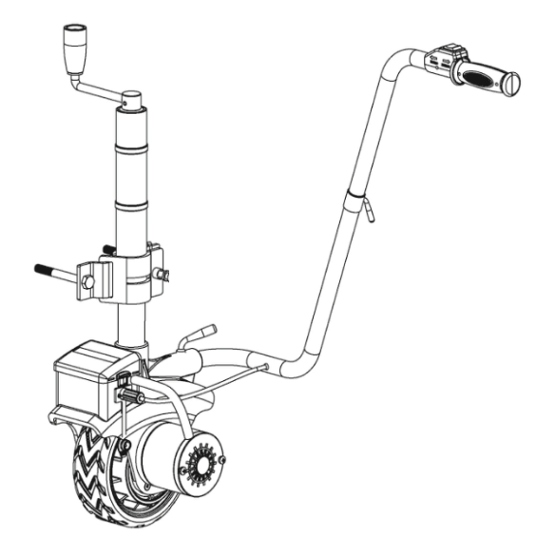

Have product questions? Need technical support? Please feel free to contact us:

**[CustomerService@vevor.com](mailto:CustomerService@vevor.com)**



**NEED HELP? CONTACT US!**

This is the original instruction, please read all manual instructions carefully before operating. VEVOR reserves a clear interpretation of our user manual. The appearance of the product shall be subject to the product you received. Please forgive us that we won't inform you again if there are any technology or software updates on our product.

**safe instructions**

This manual uses following symbols to help differentiate between different  kinds of information.The safety symbol is used with a key word to alert you  to potential hazards in operating and owning power tool. Follow all safety  messages to avoid or reduce the risk of serious injury and death.



**DANGER**

DANGER indicates an imminently hazardous

situation which, if not avoided, will result in death

or serious injury.



**WARNING**

WARNING indicates a potentially hazardous

situation which, if not avoided, will result in death

or serious injury.



**CAUTION**

CAUTION indicates a potentially hazardous

situation which, if not avoided, will result in death

or serious injury.



**CAUTION**

CAUTION used without the safety alert symbol

indicates a potentially hazardous situation which, if not avoided, will result in death

**Safety Rules**

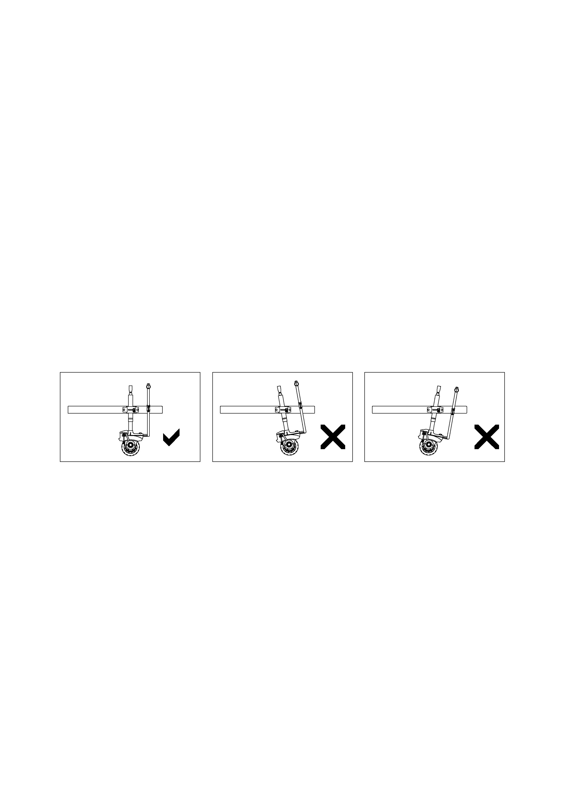

Always pay attention on Electric Trailer Mover. If the Electric Trailer Mover abnormally warps, stop working immediately.

**DANGER**

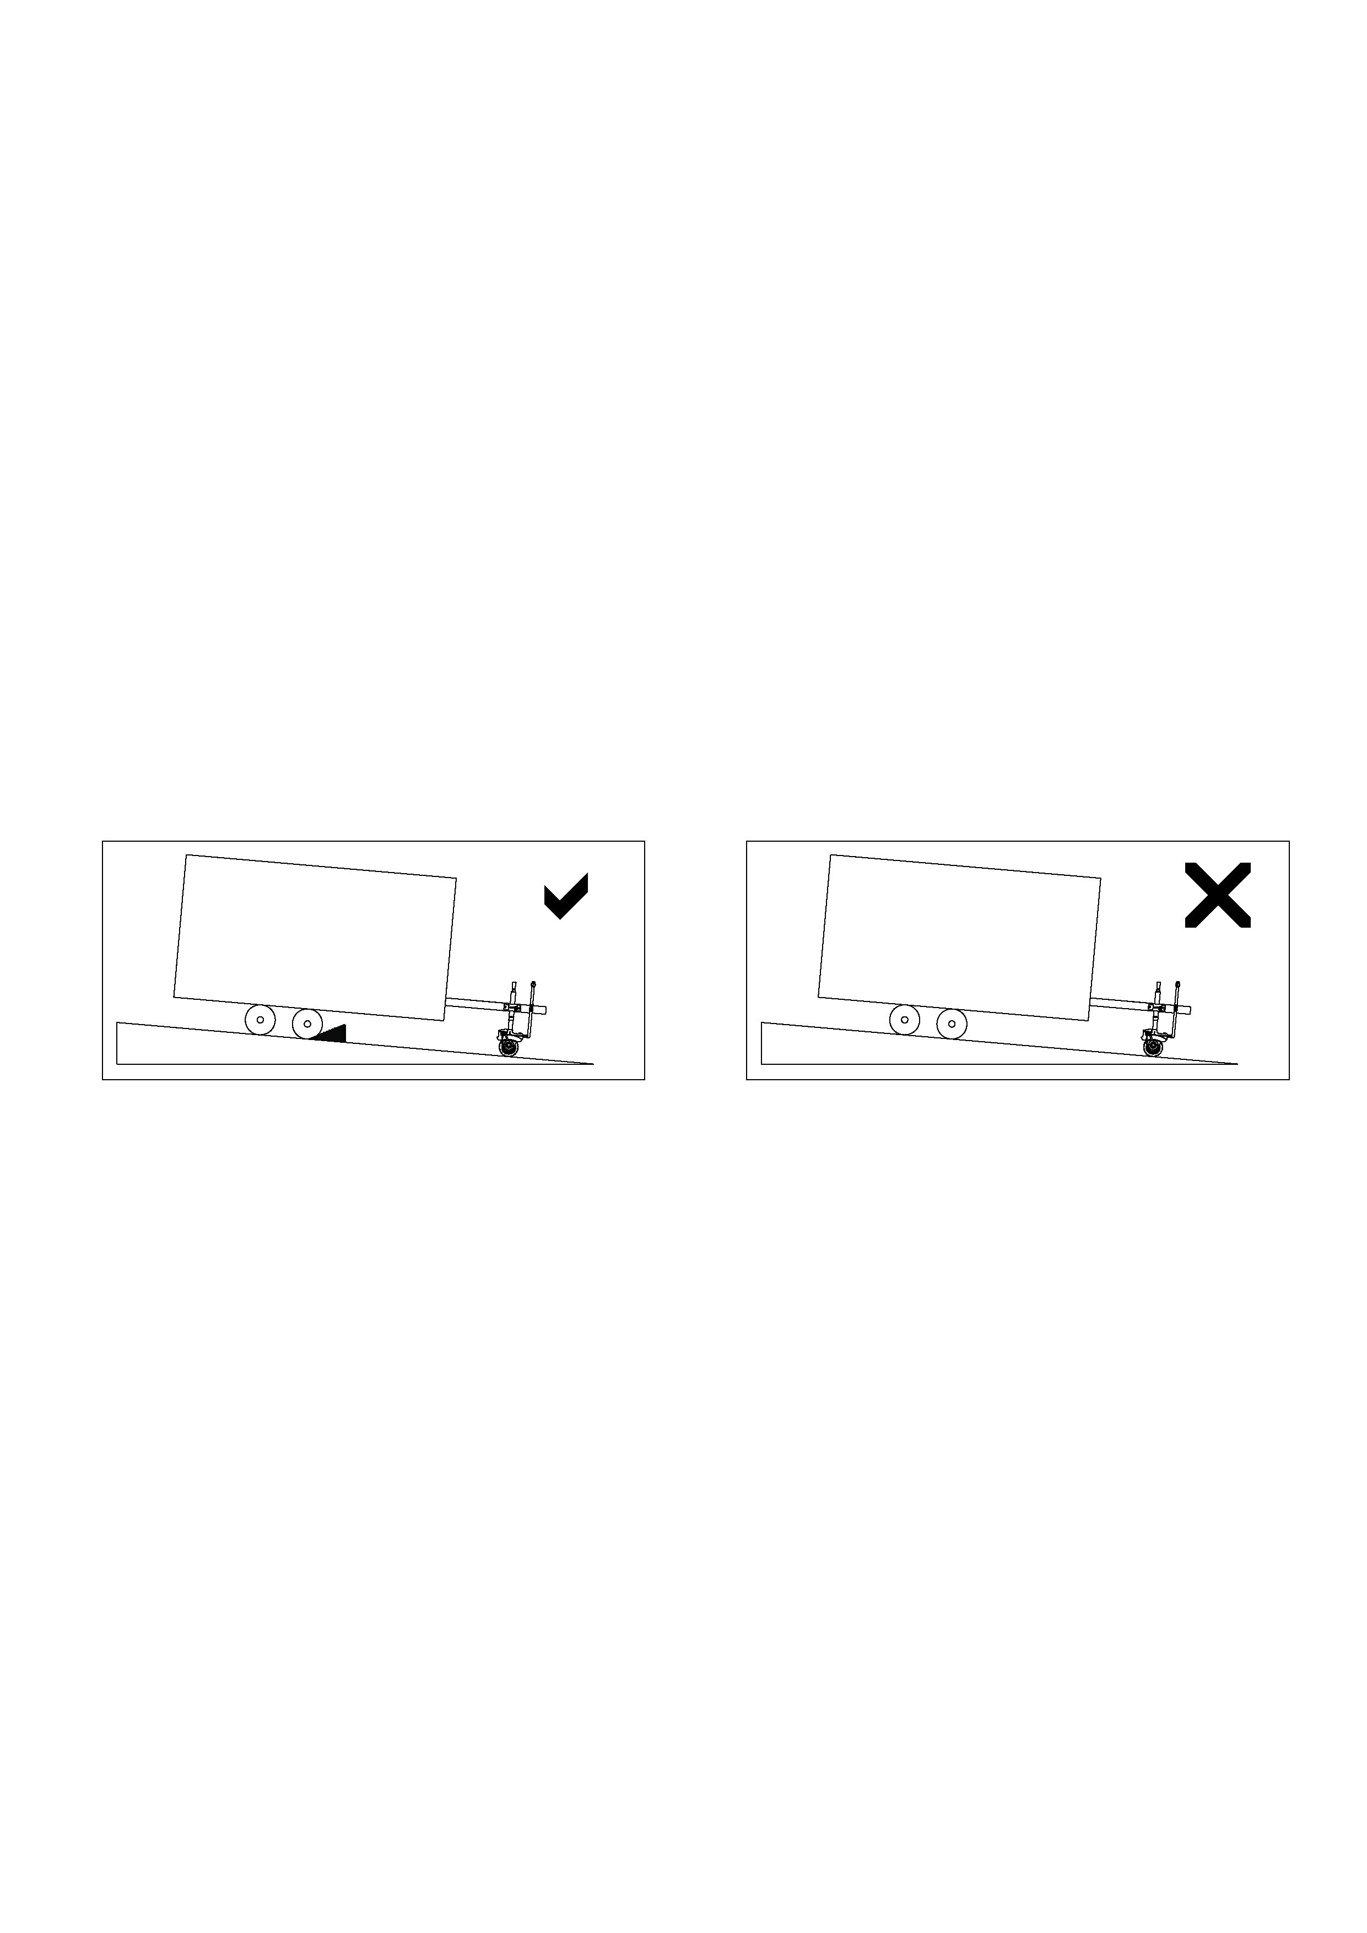

Apply blocks to the wheels of the vehicle when on an incline.



**CAUTION**

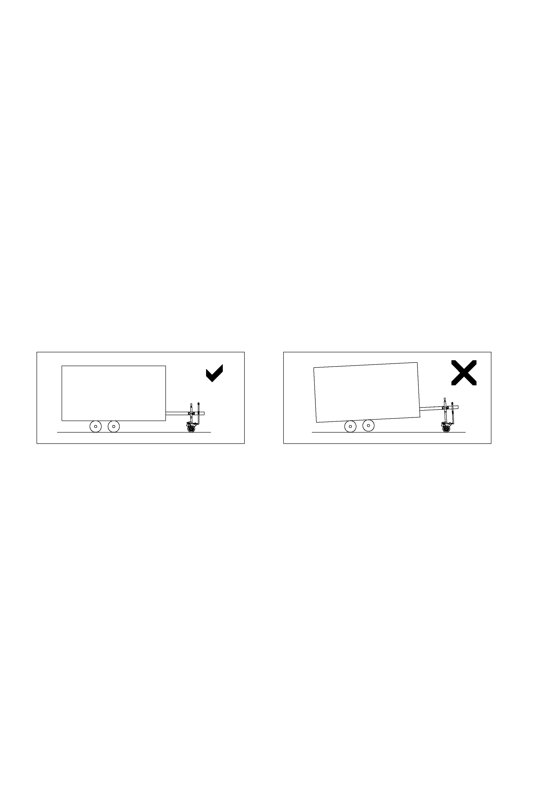

Electric Trailer Mover is able to adjust its height for easy

mounting, but Don’t lift up for moving.

**WARNING**

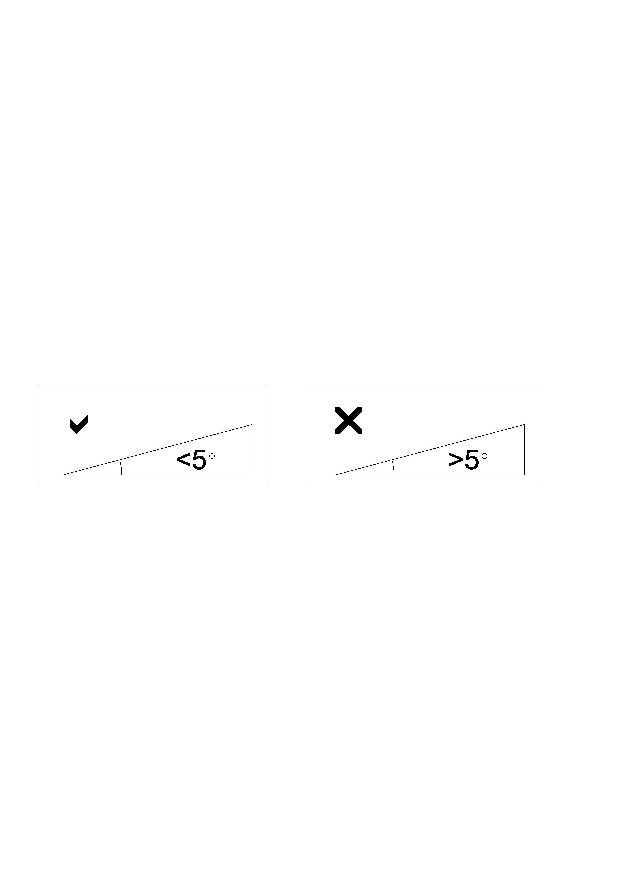

Do not push or pull vehicle on over 5 degree Gradient.

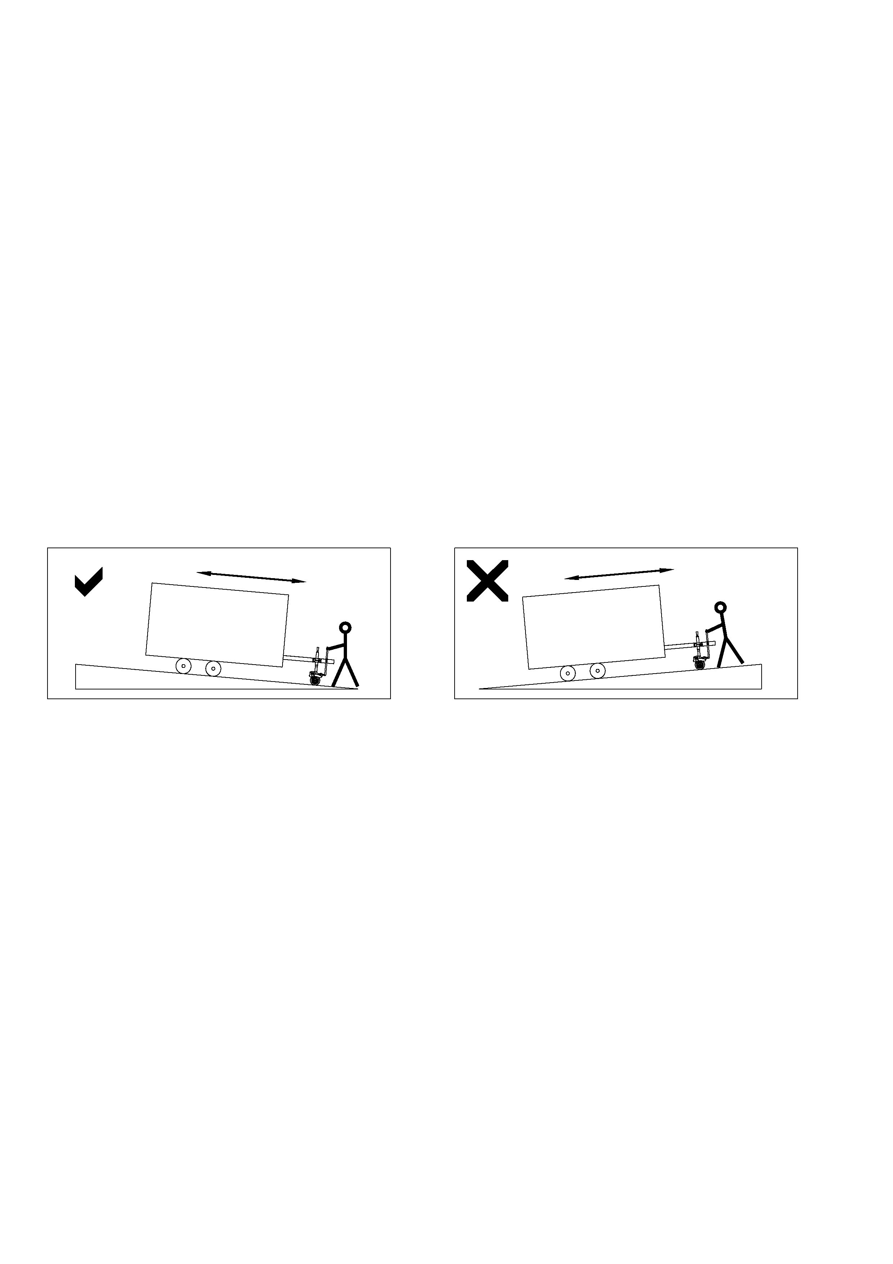

When you push or pull vehicle on gradient, Make sure Trailer Mover Stand lower position.

**WARNING**



**Safety Rules**



**DANGER**

Please observe surrounding when you working with

your Trailer Mover.



**WARNING**

Disassemble the Trailer Mover and vehicle when not in use.



**CAUTION**

Do not exceed rated capacity



**CAUTION**

Please don’t submerge Trailer Mover and/or leave it on.



**WARNING**

Battery leads are replaceable but new leads have to be less than 3M in length and over 4mm² in section.



**WARNING**

Stop working when Trailer Mover tire won’t bite on slippery surface

**Product Diagram**

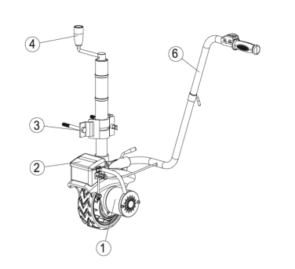

1.Motor & Gear system: DC motor provides power to the gear mechanism,  and

reduction gears converts motor power into moving force.

2.Control box: Include the electric components, and protect motor from over heat damage.

3.Clamp: It is same as normal jockey wheel clamp for fix Trailer Mover to vehicle

Chassis.

4.Lift Handle: Adjust the height of Trailer Mover.

5.Locking & Cover: The locking pin and cover prevent your Mini Mover from stolen.

6.Control Handle: It allows operator turning handle to right or left.

**Product Introduction**

SPEC.

Model

|  |  |
| --- | --- |
|  | JY01 |
| Rating(s) | 12VDC,350W |
| Load Capacity | 600lbs |
| Wheels | 8" Airless Tires |
| Speed | 6~7m/min |
| Gear ratio | 326:1 |
| Brake | Auto-brake |
| G.W | 14.5KG |
| N.W | 13.5KG |

Package Content

SPEC.

Model

|  |  |
| --- | --- |
|  | JY01 |
| Electric Trailer Mover | 1 |
| Handle | 1 |
| power cord | 1 |
| Mounting Bracket | 1 |
| Screw Kit | 1 |
| Manual | 1 |

**Product Installation & Operation Instructions**

**Step1:** Connect upper handle and under handle using lock bolt M8.

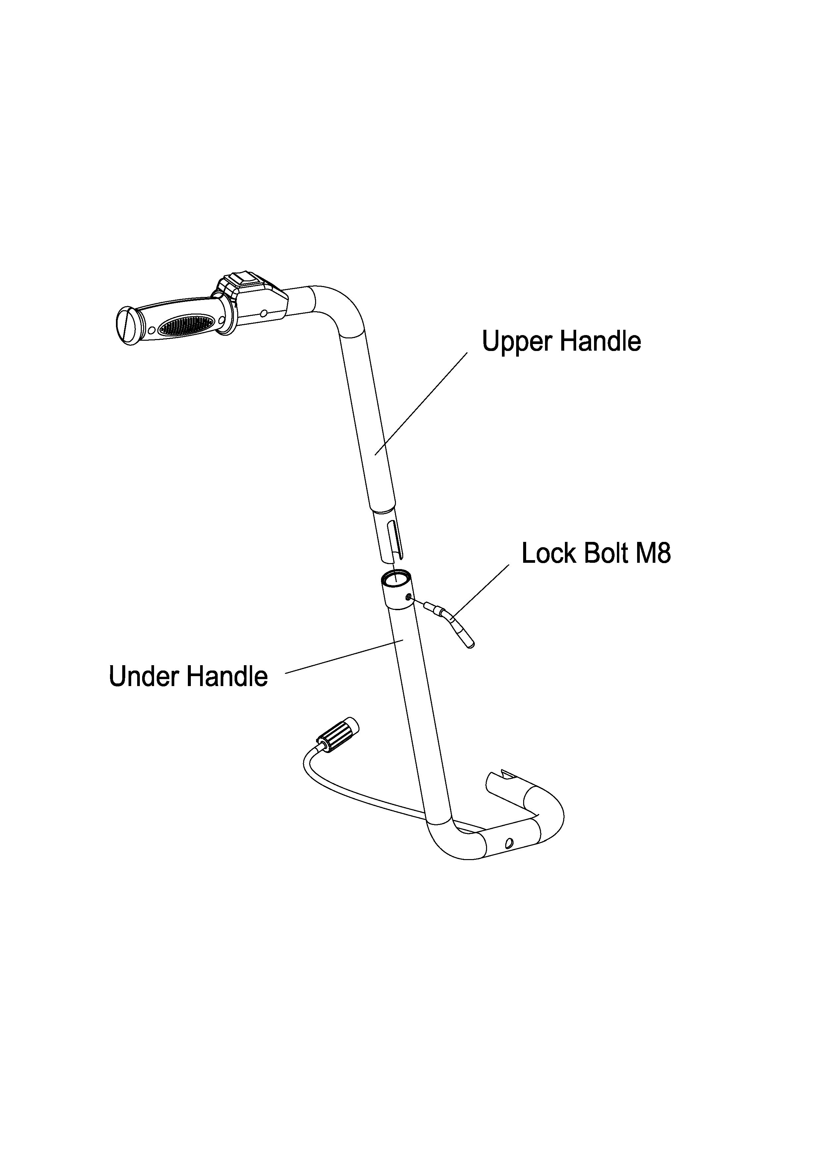

**Step2:** Attach the handle assembly to the main frame using lock bolt M14.

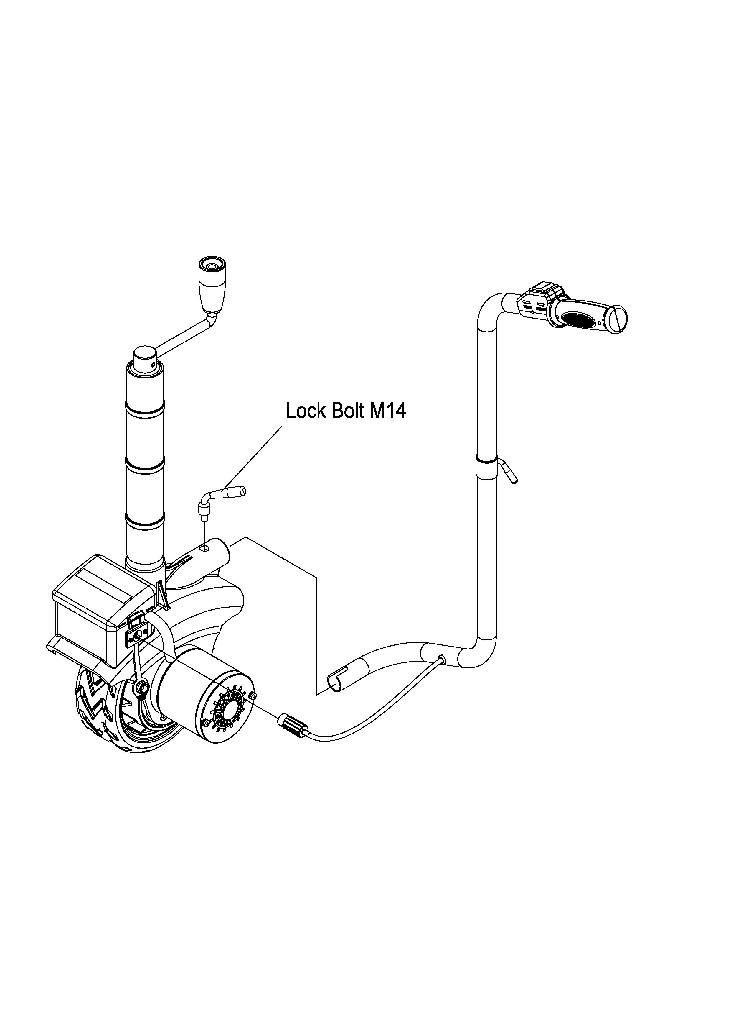

**Step3:** Insert the latch pressure plate into the latch fixed plate, then attach the latch fixed plate to the towing bracket of car using hex bolt M12x120, flat washer Ø12 and nylon lock nut M12.

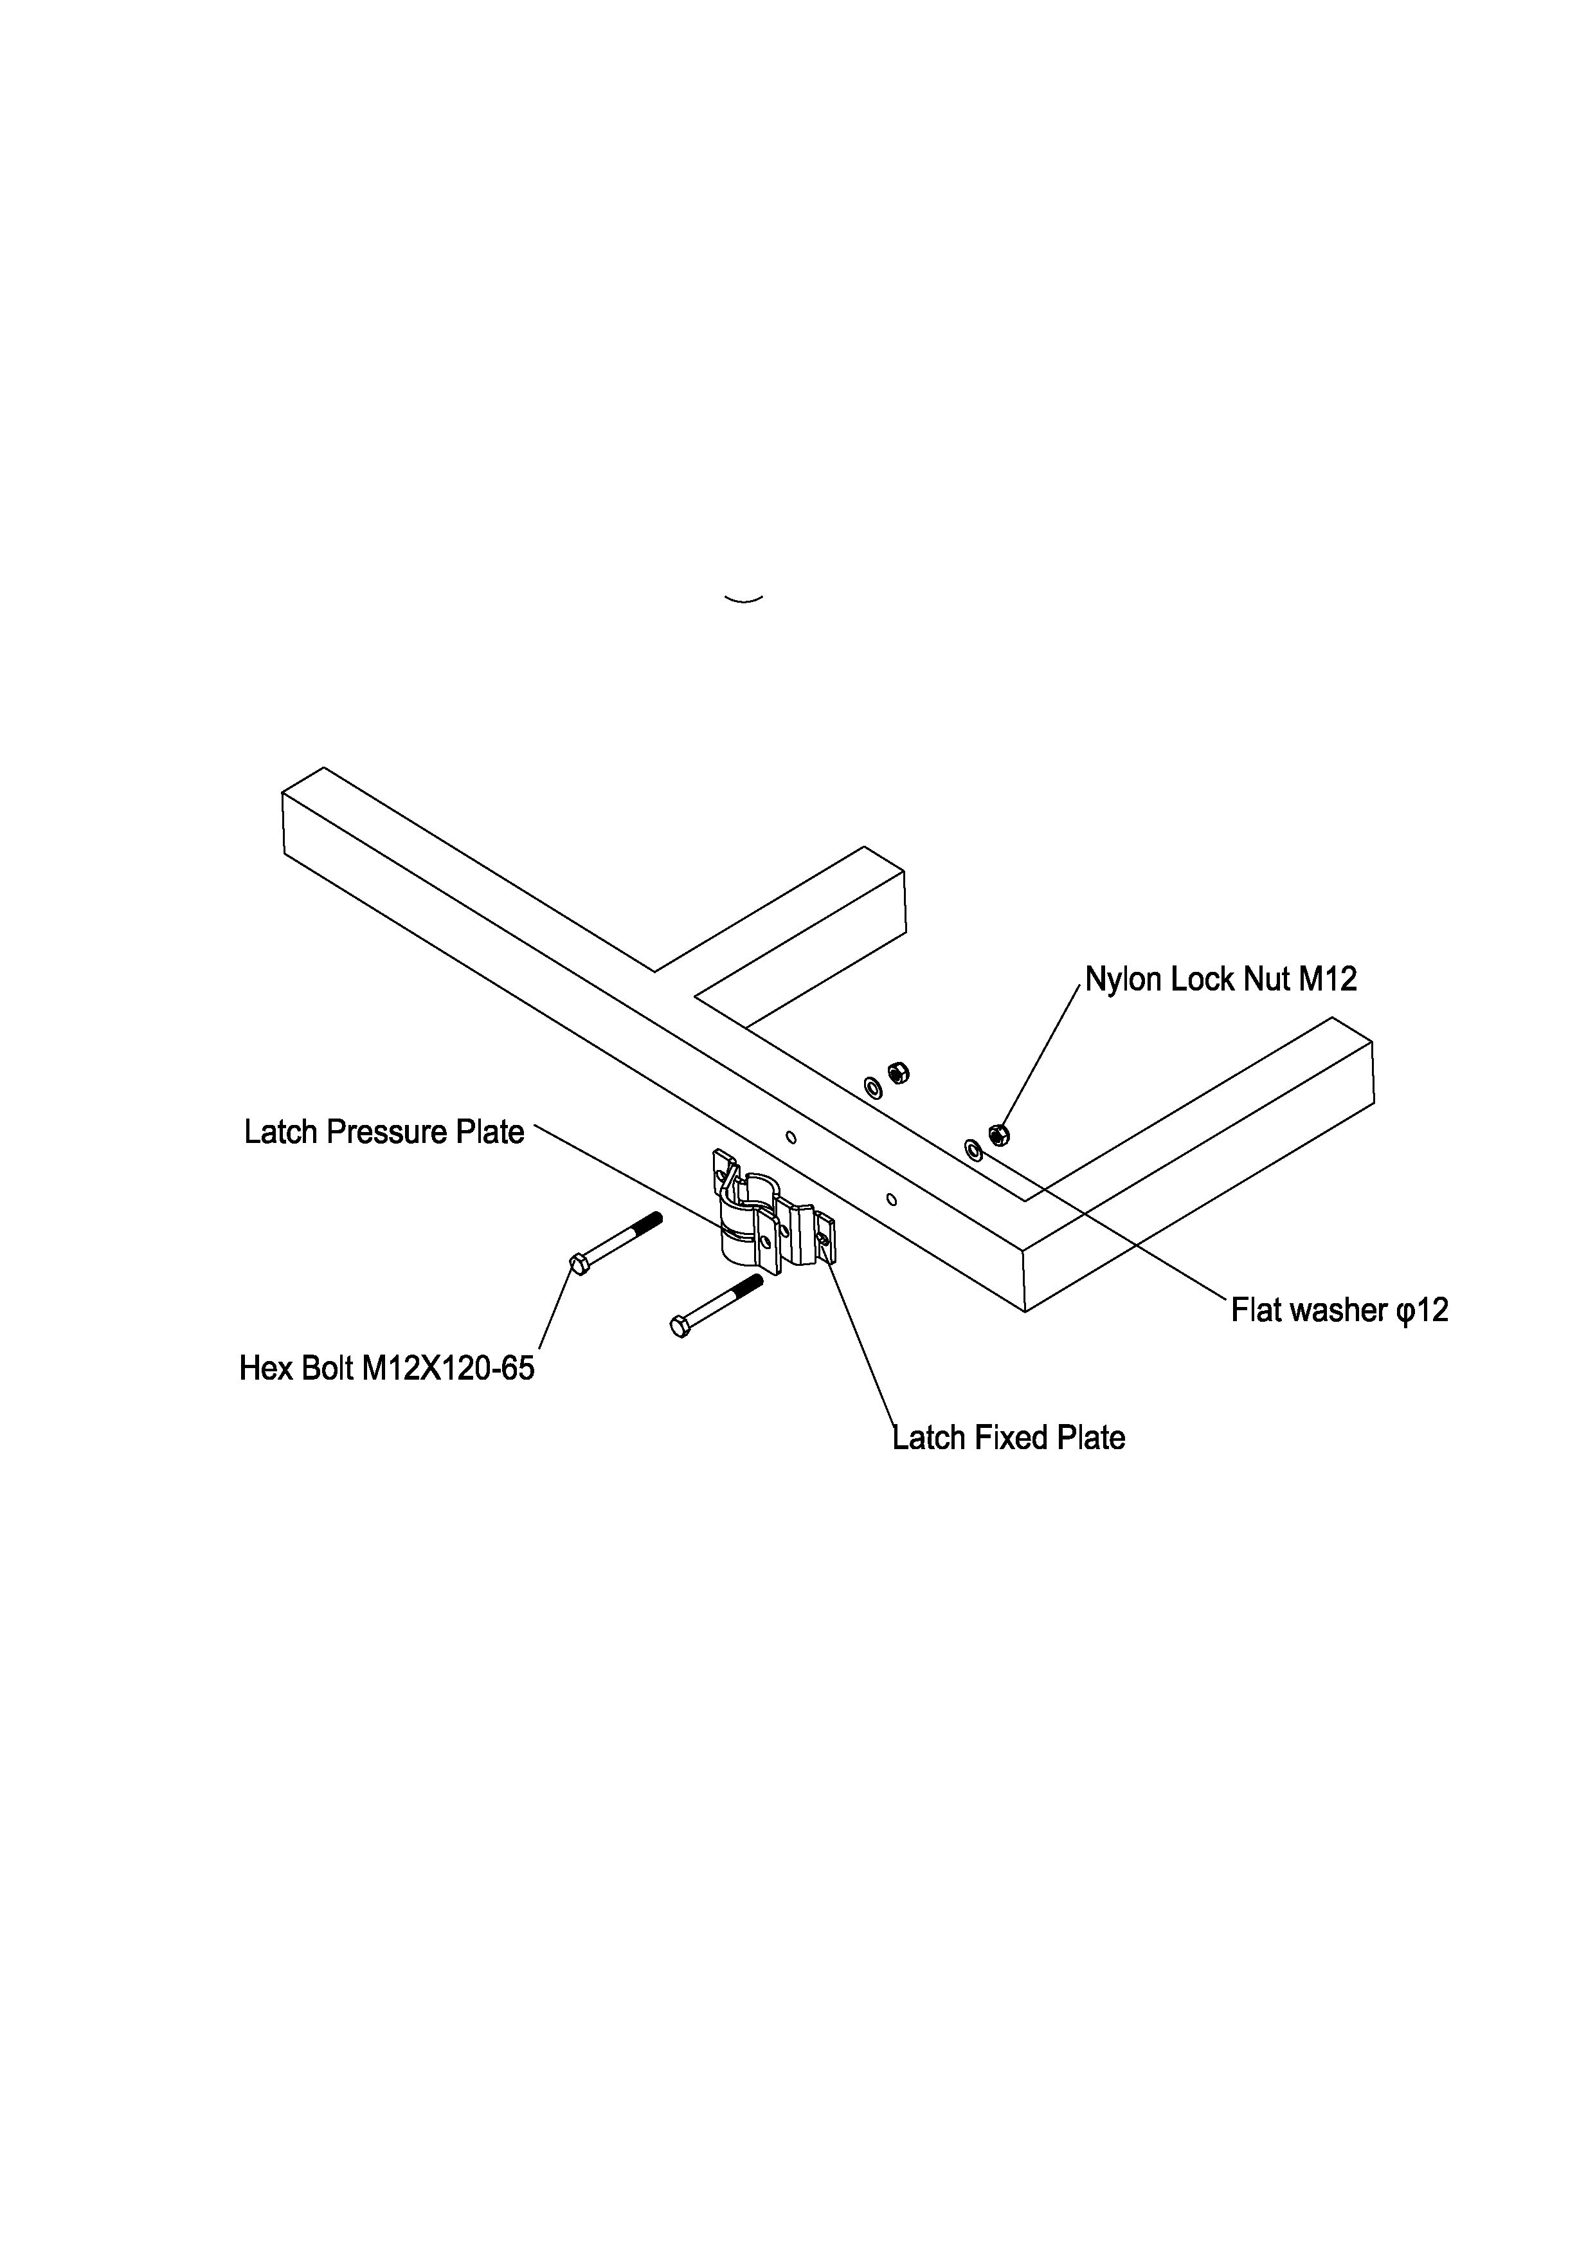

**Step4:** Compress the latch pressure plate using lock pin and lock.

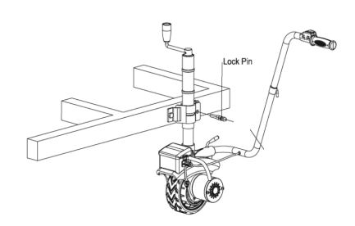

**Step5:** Insert one head of power cord into the socket of Trailer Mover, connect the other head of power cord to the battery. Note the battery is negative.

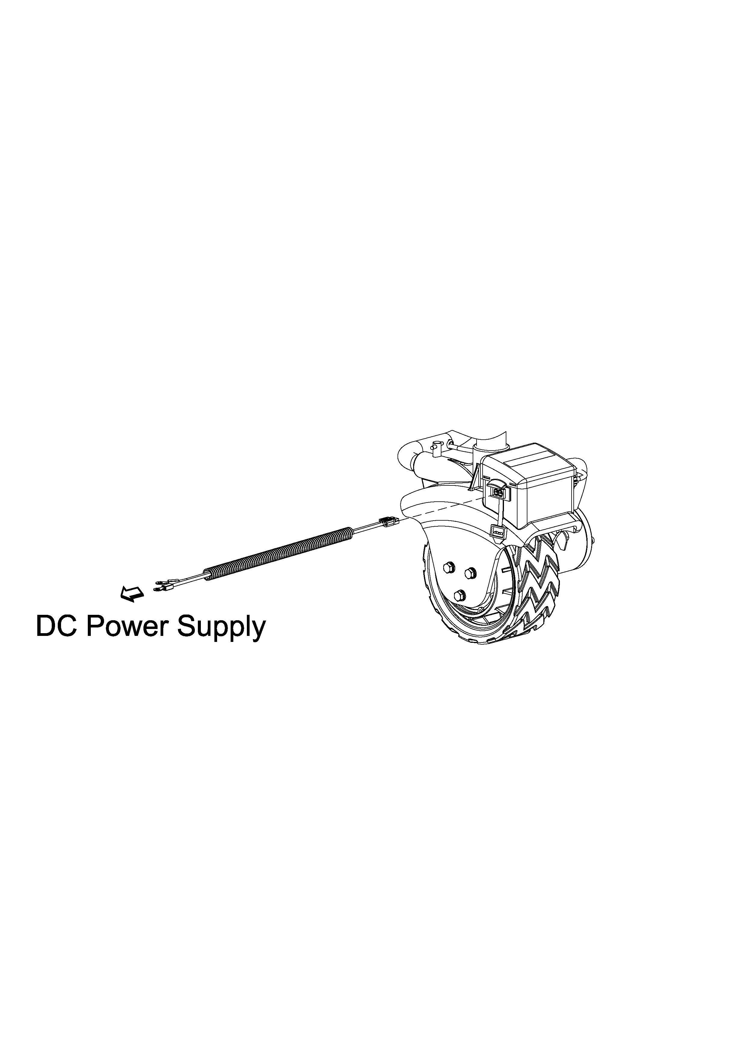

**Step6:** Button the red power switch processing circuit, and make sure the tire route.

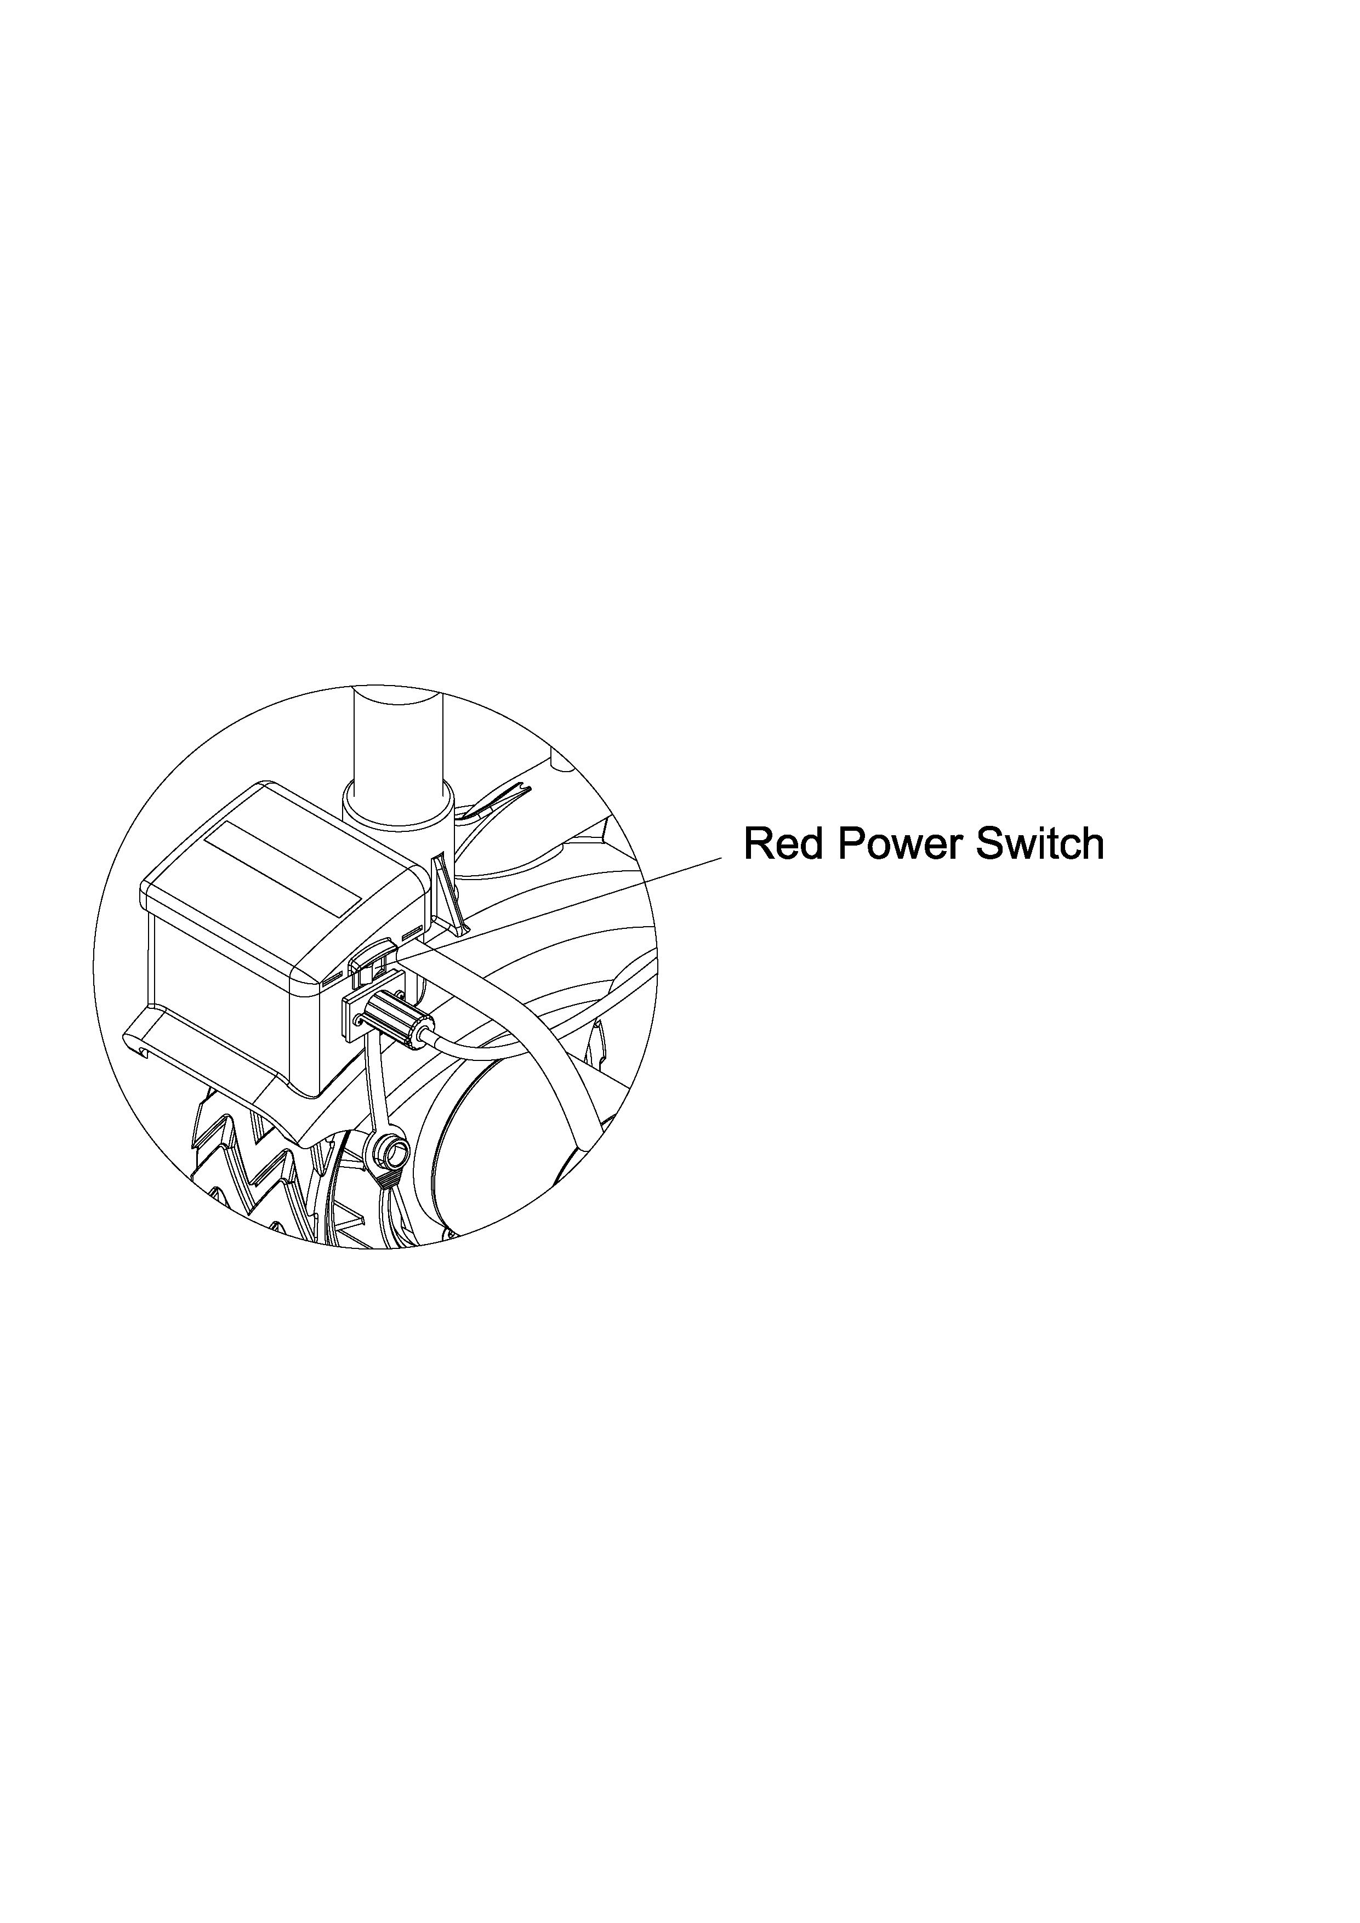

**General tips for safe operation**

1.Electric Trailer Mover is rated at 2270kg pulling weight and 272kg jockey wheel load. Overloads can damage the Mini Mover, motor, tire etc.

2.Check if the handle positioning key totally screwed with Mini Mover

before you start operation.

3.Check if battery leads correctly connect to battery terminals.

4.Don’t use leads that being shattered, squashed or any damage.

5.Avoid rainy day when use the machine under the condition of open-air.

**Operation guide**

\*Take time to access your situation and plan your movement.

\*Clamp your Mini Mover with vehicle chassis. Locking pin and cover is recommended for every single time usage.

\*Fix the handle and connect handle leads to control box, and connect battery leads to battery terminal.

\*The press button向上直线箭头shall means forward,  向上直线箭头shall means backward.

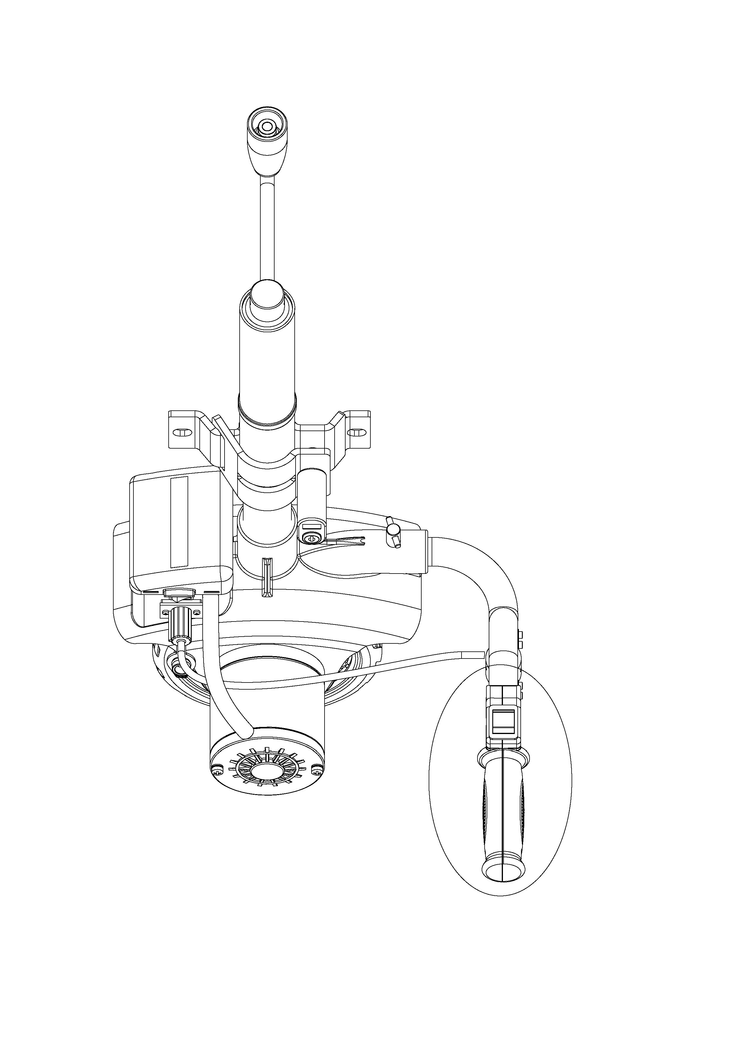 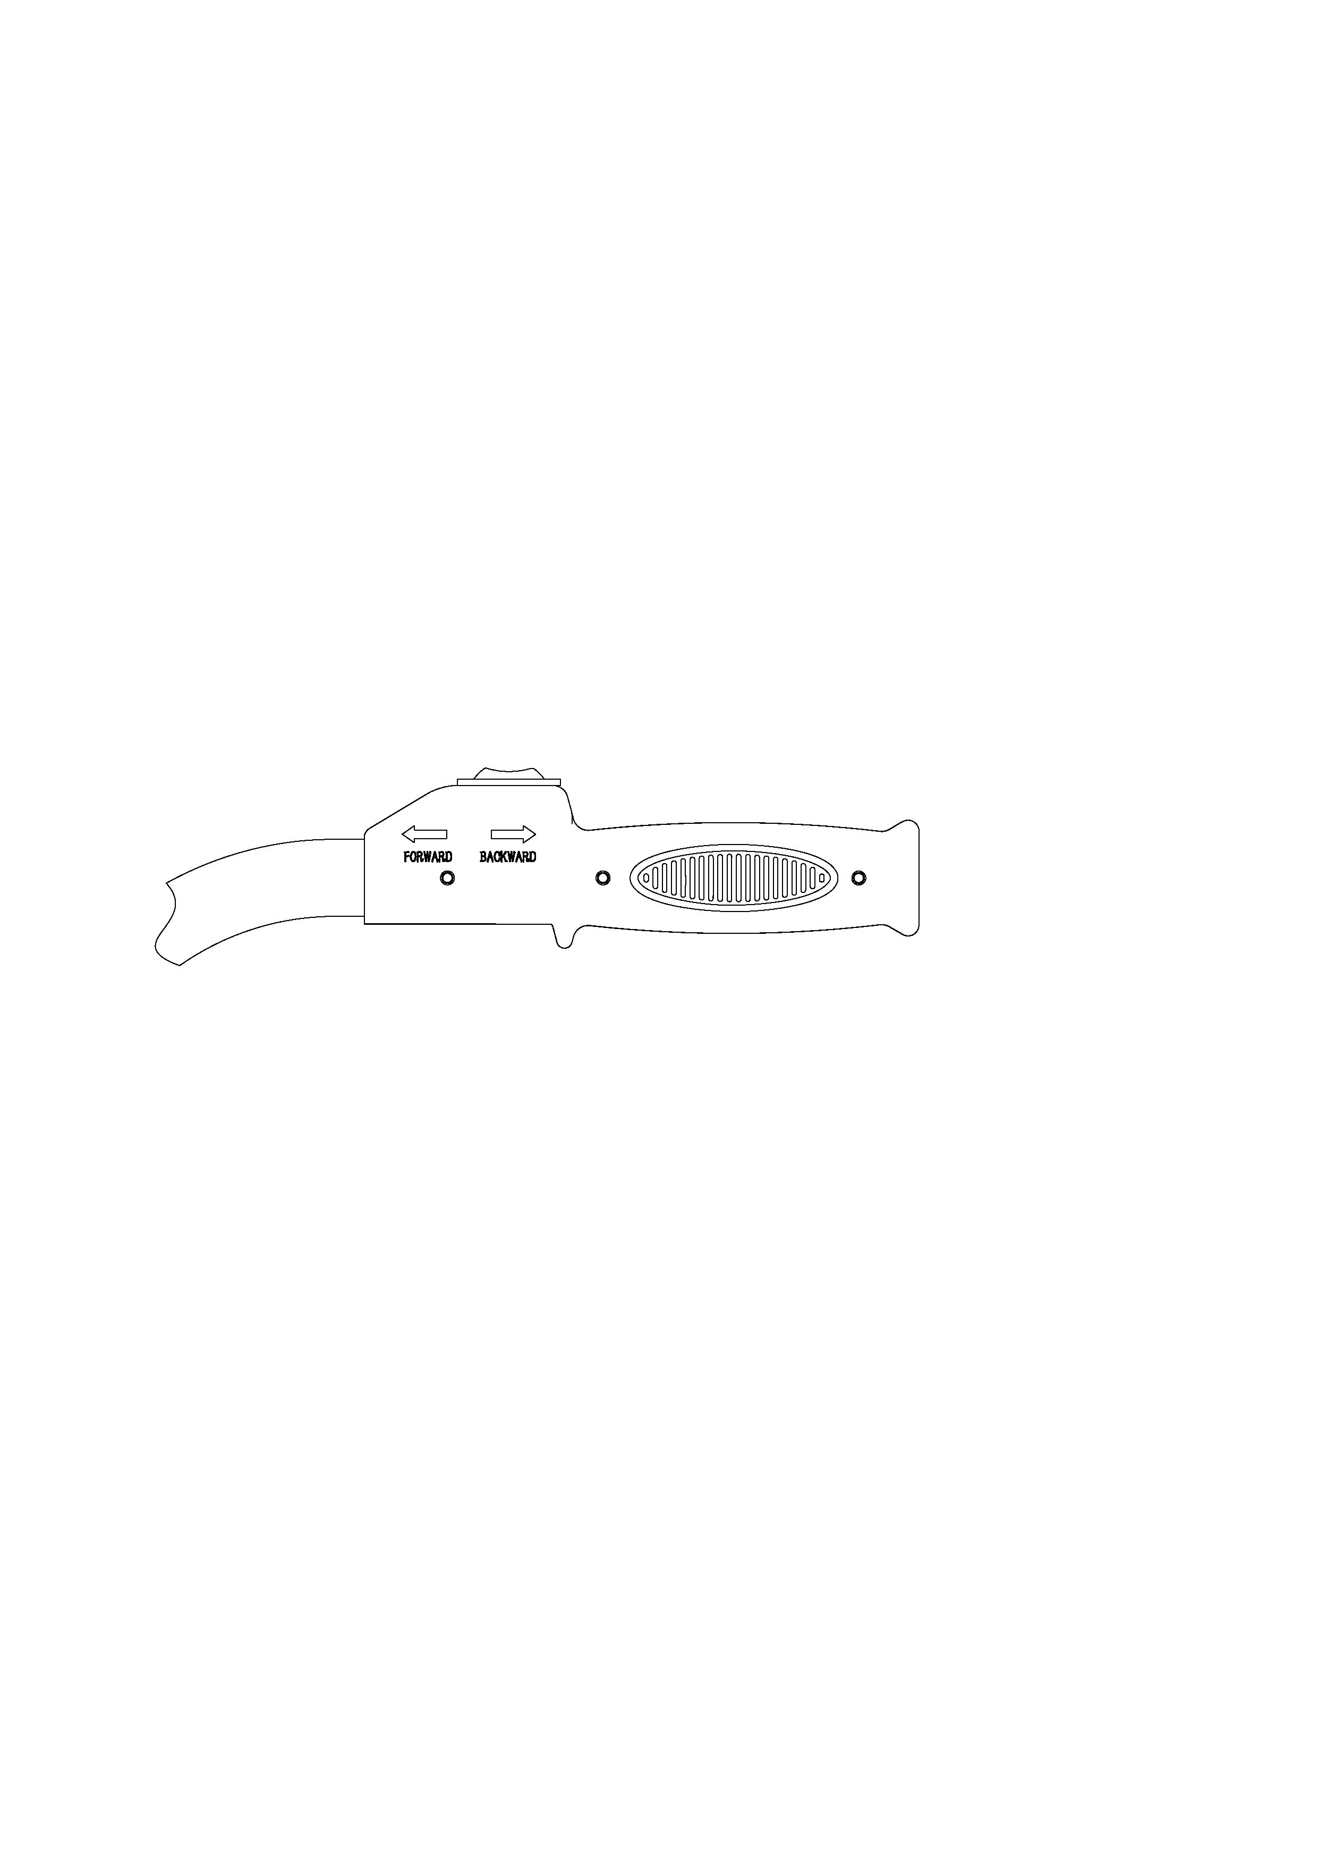

**Troubleshooting, Maintenance and Repair**

All moving parts within the Trailer Jack have been Lubricated using high temperature lithium grease at the factory. No internal lubrication is required. If the Mini Mover being used in high moisture circumstance for long time and internal lubrication is necessary, please ﬁnd a professional technician for maintenance.

**Trouble shooting**

|  |  |  |
| --- | --- | --- |
| **Problem** | **Cause** | **Solution** |
| Motor does not turn on | * Circuit breaking * Battery leads connection loose * Electric contactor fault * Motor fault * Circuit protector activated because of overheat | Press red switch on control box  Screw the leads tight with battery terminal.  Open the control box,check whether plug loose,the line for open circuit.  Replace the motor.   * Stop working 5 min for cooling down |
| Electric contactor fault motor speed low | Low voltage or too much weight on vehicle | Recharge the battery or check weight of vehicle |
| Electric contactor fault  Slippery on tire | * Electric contactor fault * Over load or moving on more than 5 degree incline | * Replace electric contactor * Give up moving |
| Electric contactor fault noise | * Electric contactor fault * Over load or moving on more than 5 degree incline | Decrease load weight |

**Importer:** WAITCHX

**Address:** 250 bis boulevard Saint-Germain 75007 Paris

**Importer:** FREE MOOD LTD

**Address:** 2 Holywell Lane, London, England, EC2A 3ET

**Manufacturer:** WUYI DOUBLEZEN MACHINERY CO.,LTD

**Address：**FENGHUASHAN INDUSTRIAL ZONE WUYI, ZHEJIANG , CHINA

**Made In China**

**REP**

**UK**

EUREP UK LTD

UNIT 2264, 100 OCK STREET, ABINGDON

OXFORDSHIRE ENGLAND OX14 5DH

**REP**

**EC**

EUREP GmbH

Unterlettenweg 1a, 85051

Ingolstadt, Germany

****

**Technical Support and E-Warranty Certificate**

**[www.vevor.com/support](https://www.vevor.com/support" \t "_blank)**